JR6001 Voice Playback Module + Circuit Explanation
The JR6001 voice playback module has a built-in USB interface and can flexibly replace the voice content stored in the SPI flash. It eliminates the trouble of using host software to replace audio on traditional voice chips. The SPI flash is directly emulated as a USB drive, so files can be copied to it just like a normal USB flash drive, which is very convenient. It is supported by virtually any computer system.
I. Module Features
1. Supports high-quality MP3 and WAV audio formats with pleasant sound.
2. 24-bit DAC output, dynamic range up to 90 dB, signal-to-noise ratio 85 dB
3. Supports two-wire serial control and AD control
4. USB updating of voice files, with no driver installation and no software installation required. Files can be copied directly, making the process fast and convenient. Supports XP
systems, as well as WIN7, WIN8, and WIN10.
5. Supports common control functions such as previous track, next track, play, pause, stop, and track selection
6. Supports freely combined playback
7. Supports 30-level volume adjustment.
8. Supports playback count setting for broader and more user-friendly applications
9. Dedicated BUSY signal output indication
10. Mature commands and command parsing for more stable applications
11. Dedicated host software for quick start, convenient debugging, and automatic command generation.
II. Application Fields
1. Industrial control: industrial equipment, control equipment, etc.;
2. Intelligent transportation devices: toll stations, parking lots, in-vehicle voice prompts; 3. Advertising industry: advertising message playback;
4. Access control and attendance: door opened, verification passed, etc.;
5. Security industry: human body sensing prompts, safety voice prompts, friendly reminders; 6. Gaming industry: rocking machines, bumper cars, basketball machines, etc.;
7. Medical electronics: calling devices, queue calling machines, etc.;
8. Educational communication: educational equipment, communication electronics
IV. Hardware Parameters
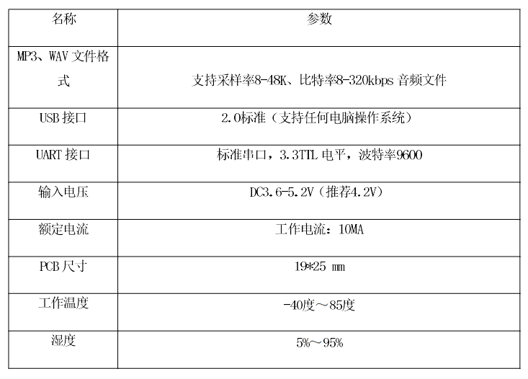
V. Pin Description
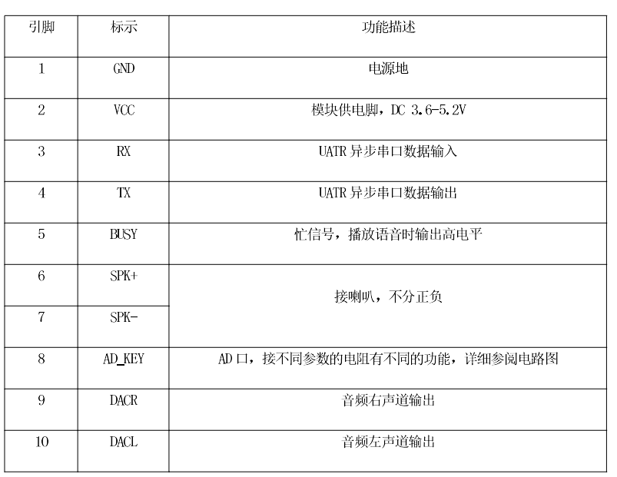
VI. The module circuit interface diagram is shown below.
Module circuit interface diagram
VII. The physical picture of the module circuit is shown below.
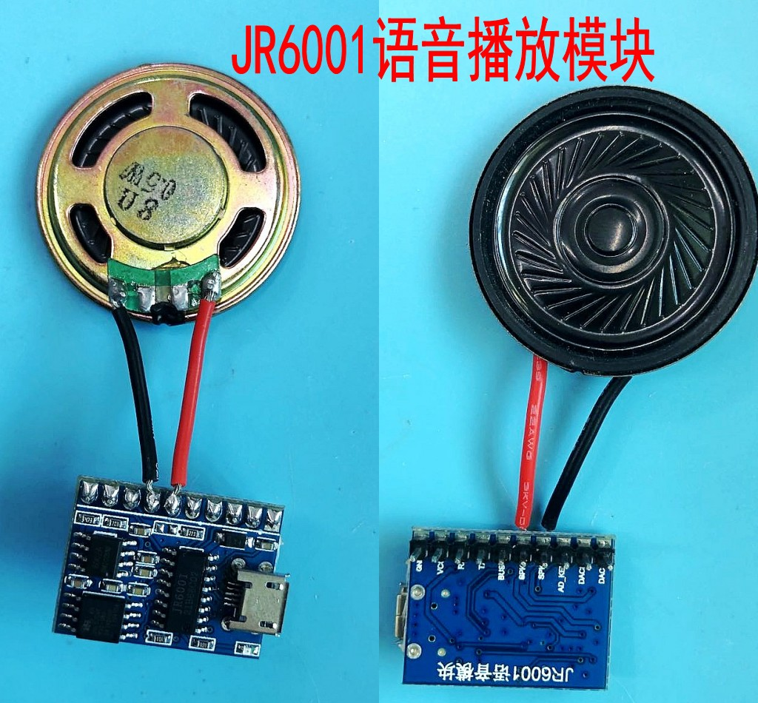
Module physical picture

